Software Development and Object Oriented Design

asdas

**CSE 4510**

**Project Documentation**

**Project Title:** E-Commerce Center (OpenShop)

**Members:**

Saadman Malik (154420)

Md. Mezbaur Rahman (154401)

Shahed Ahmed (154418)

Summary:

* It is a website for transaction of buying or selling products online
* It gives an online platform for electronic business deals
* It allows consumers to electronically exchange goods and services with no time or distance barriers
* It creates an easy communication and negotiation room for transaction among the buyer and seller

Description:

Now let’s point out the features of our project,

**Features:**

* A buyer or a seller have its own particular account in the website
* The seller can upload their product along with their desired price and picture of the product and with other editable features and details
* A buyer can go through various categories and subcategories of products for sell and can communicate with the seller for the desired product
* The product will be shown from the database as the customer desires, for example sorted by category, sorted by price, and sorted by new or used product.
* The buyer will have a ‘add to favorites’ or wish list section to keep tag of the interested product they wish to buy
* The buyer can order a product via shipment process or they can have the sellers contact number to negotiate among themselves about product transaction
* There are particular number of shippers assigned to a particular district for product shipment. Each shipper takes four orders a day and can take pre-order for the upcoming week. Our system tries to provide the buyer with the earliest delivery date possible depending on the workload of the shippers at that particular district.

Now let’s point out the raw materials to build this website,

**Raw materials of our project:**

1. Front end structure was done by HTML 5.
2. CSS (Cascading Style Sheet) was used for designing and for enriching the user interface of the website.
3. Back end server side development was done by PHP.
4. Front end logic was applied by JavaScript.
5. PhpMyAdmin was used to handle back end database using MySQL

Use Case Diagram of our project:

1. User sign-up, login verification and logout:

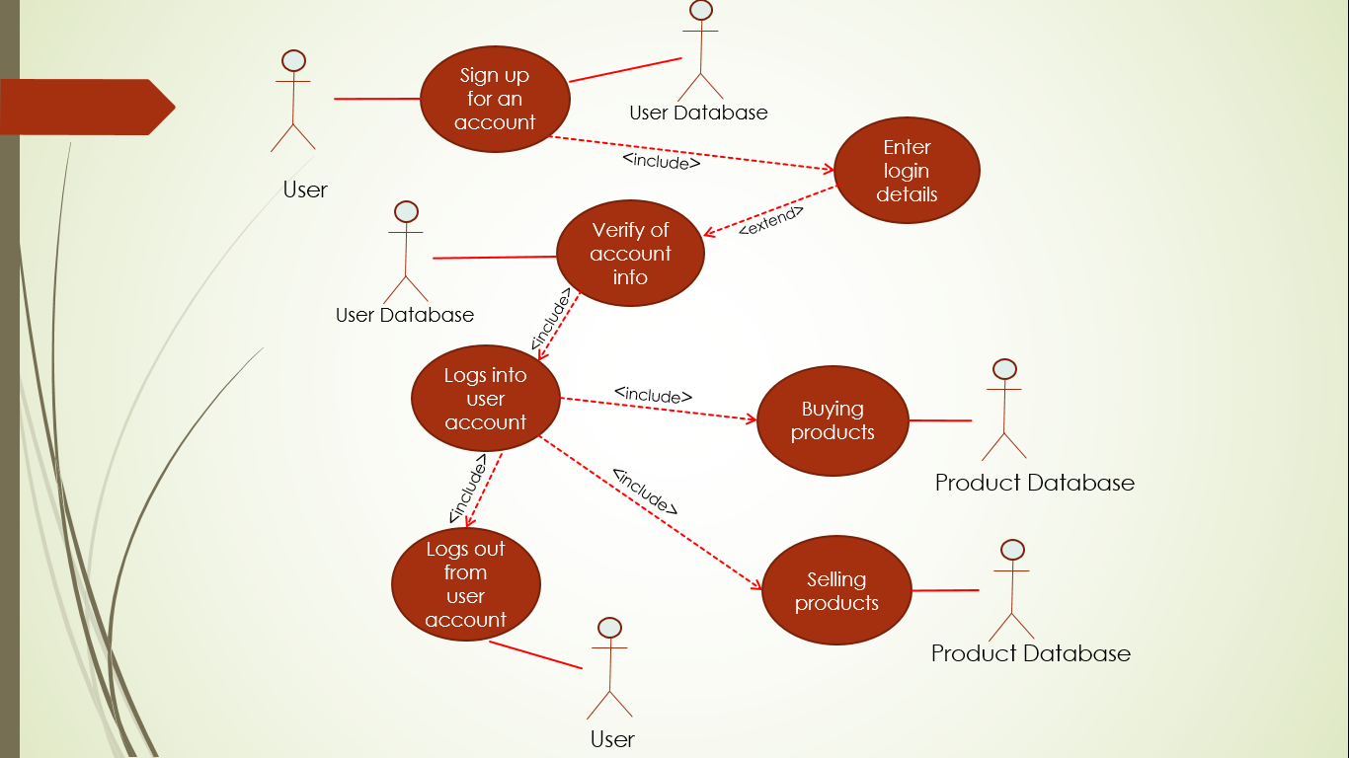

1. Buying Products:

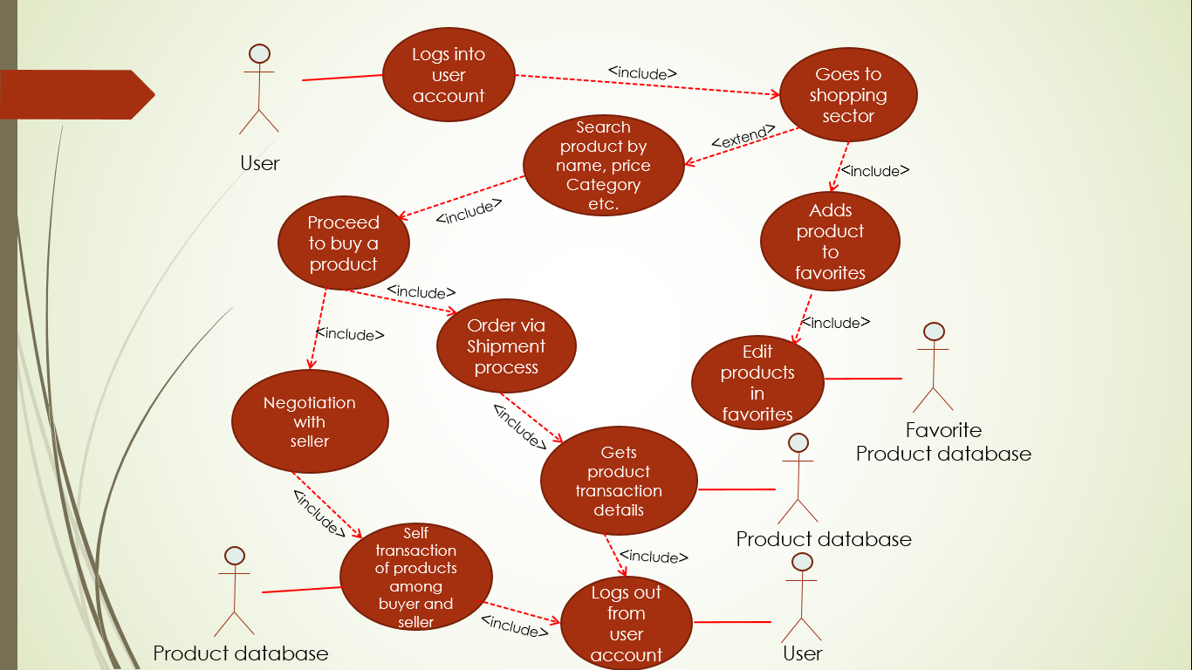

1. Selling products:

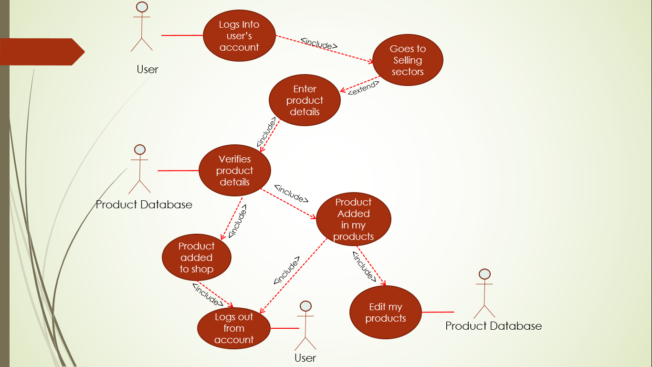

ER diagram of our project:

The ER diagram of our project is given below:

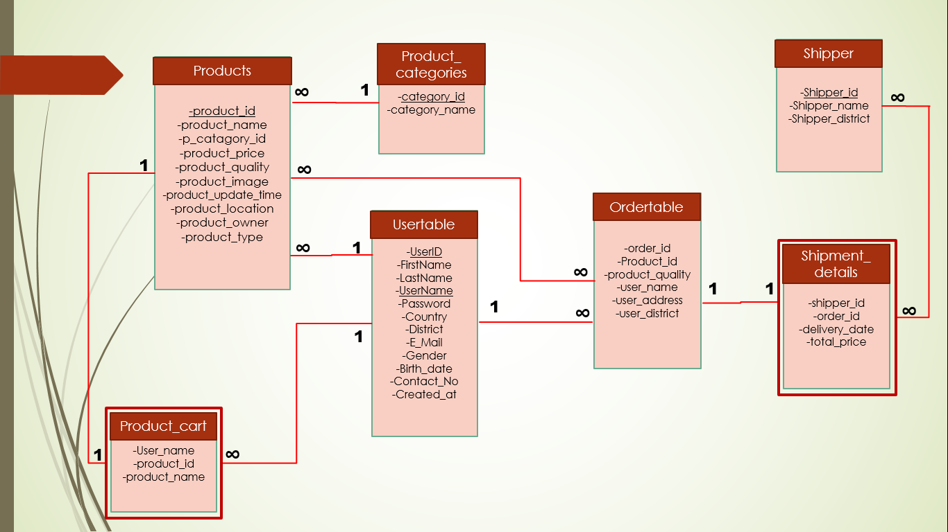

Overview of our project:

* This is the home page of our project.

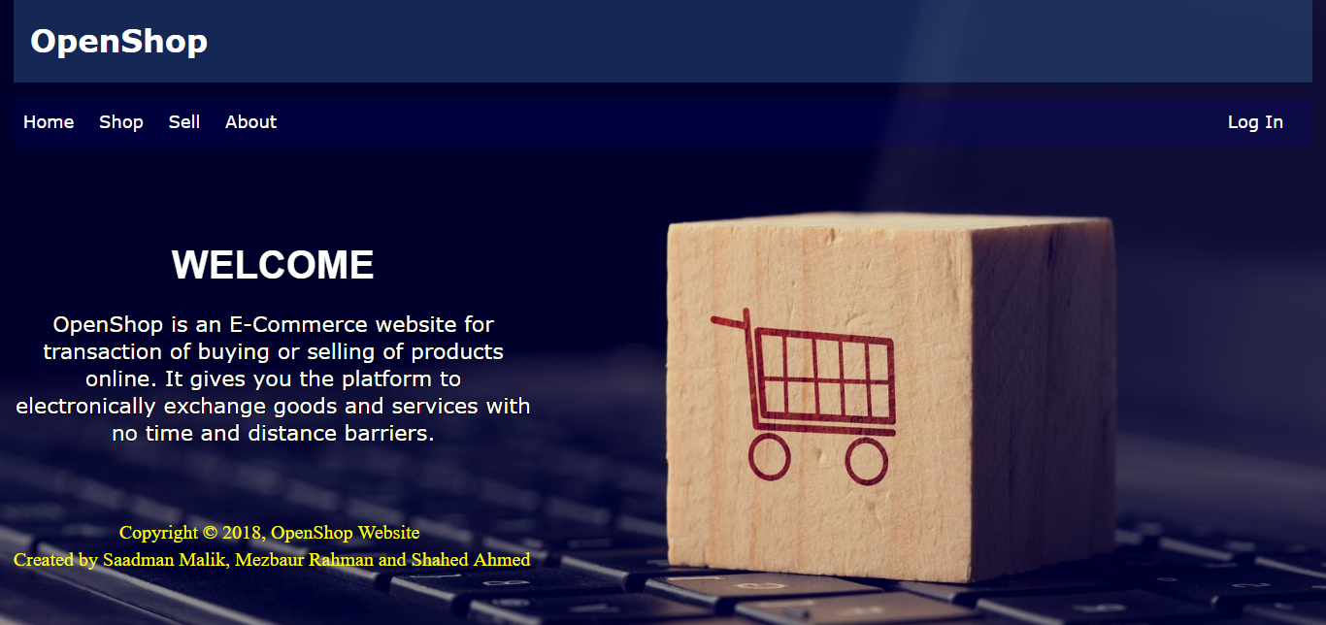

* This is our login page.

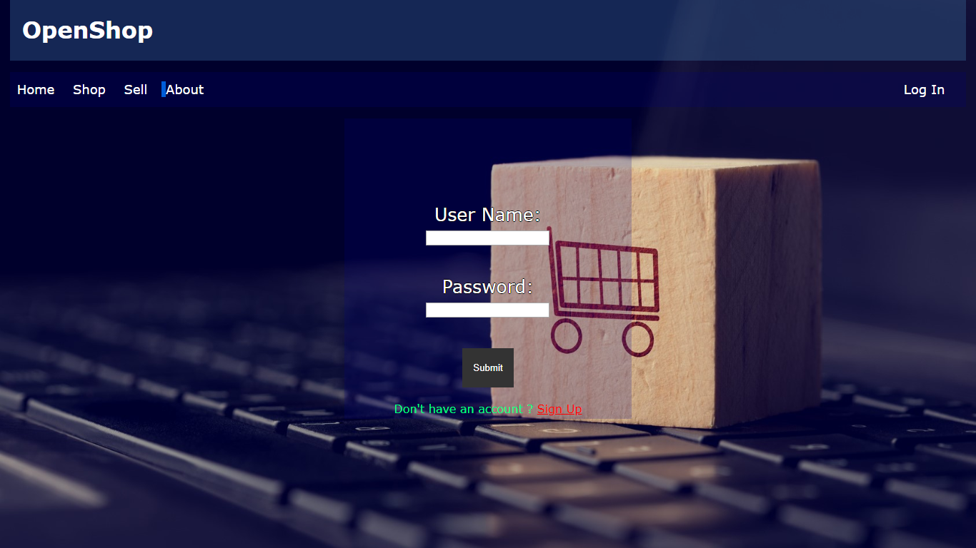

* This is our sign up page.

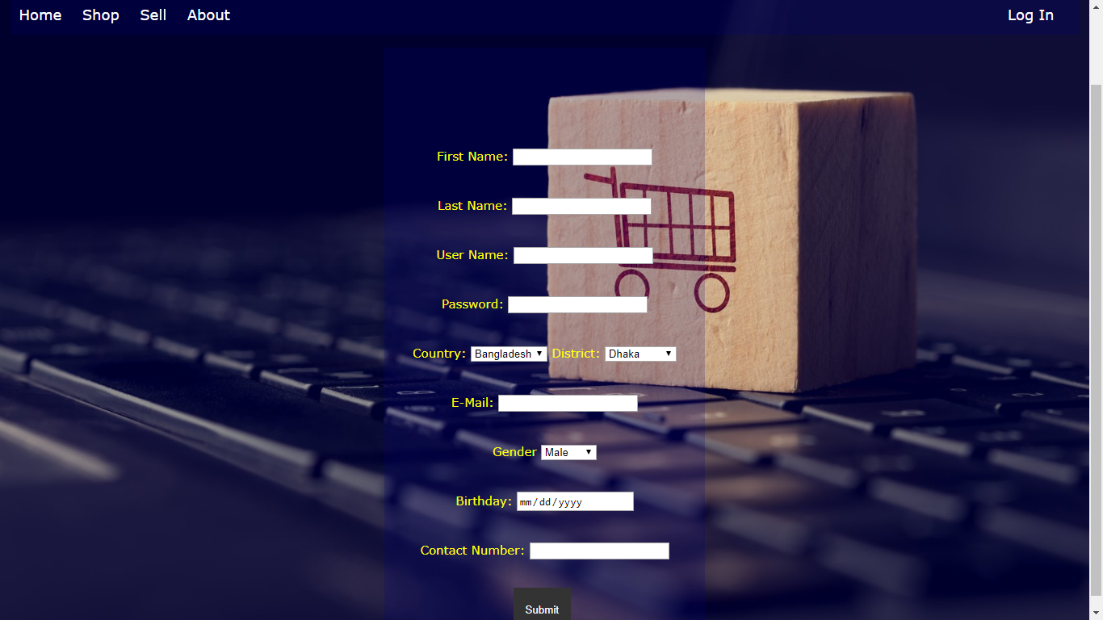

* This is our home page after a user logs in to his account.

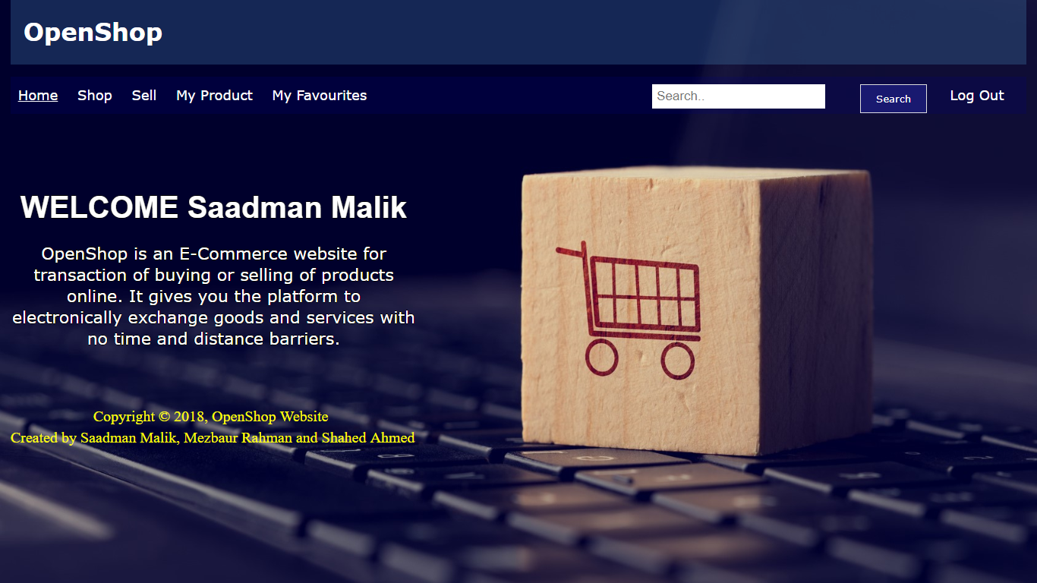

* This is our shop page where user can buy different products and can even search products based on its different requirements.

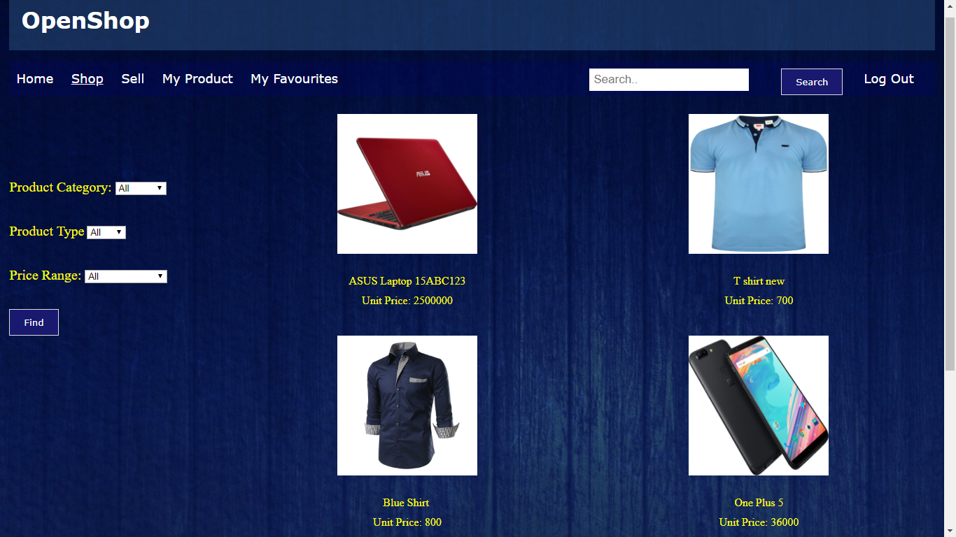

* This is our sell page where user can sell products of his own.

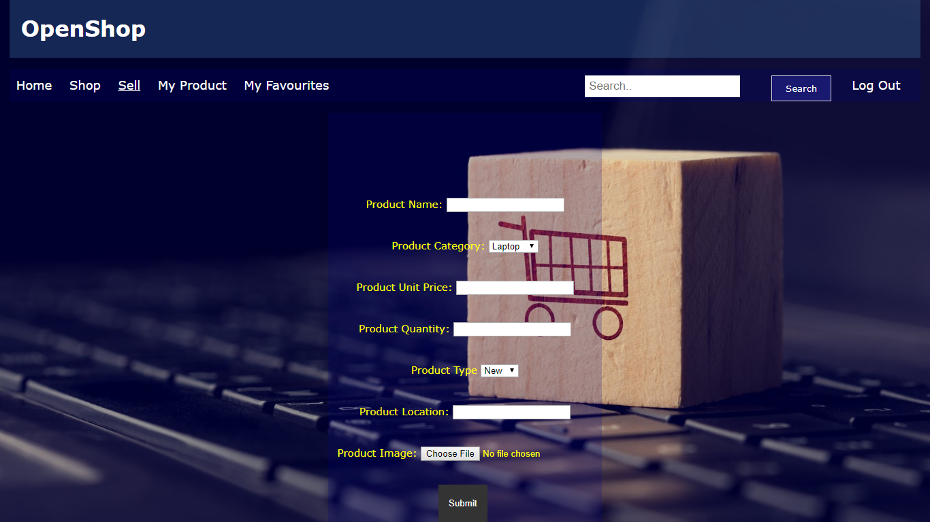

* This is the ‘my product’ page. The products uploaded by the user for selling can be viewed in ‘my products’. The user can edit its product from here also.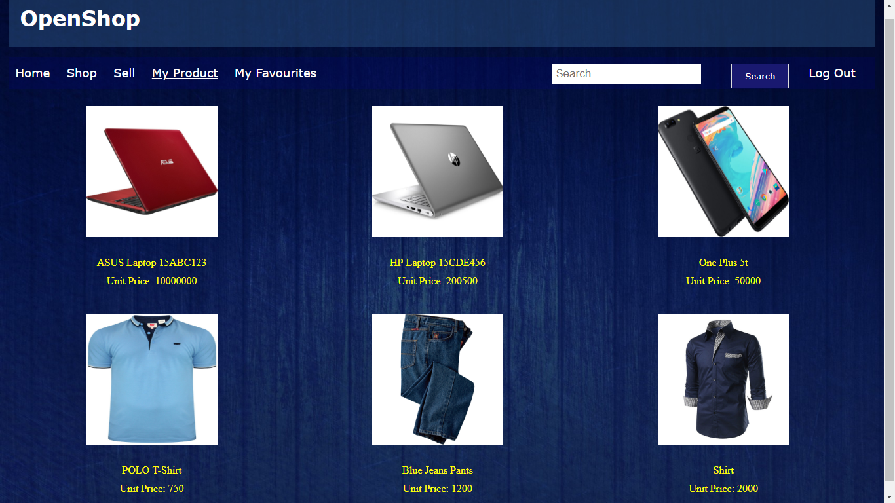
* This is our ‘my product’ details where user can edit its product.

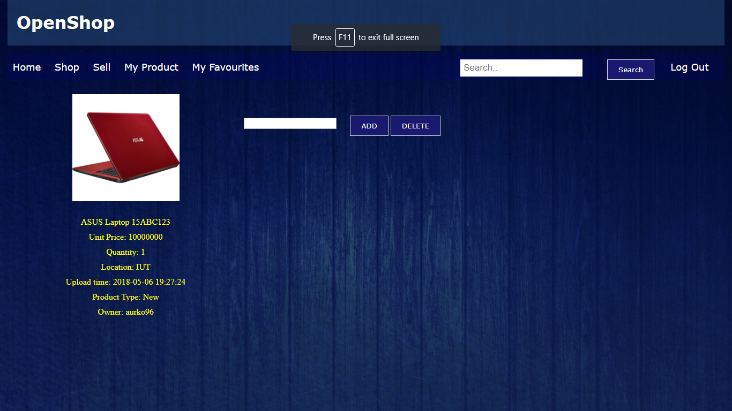

* This is the ‘my favourites’ page.

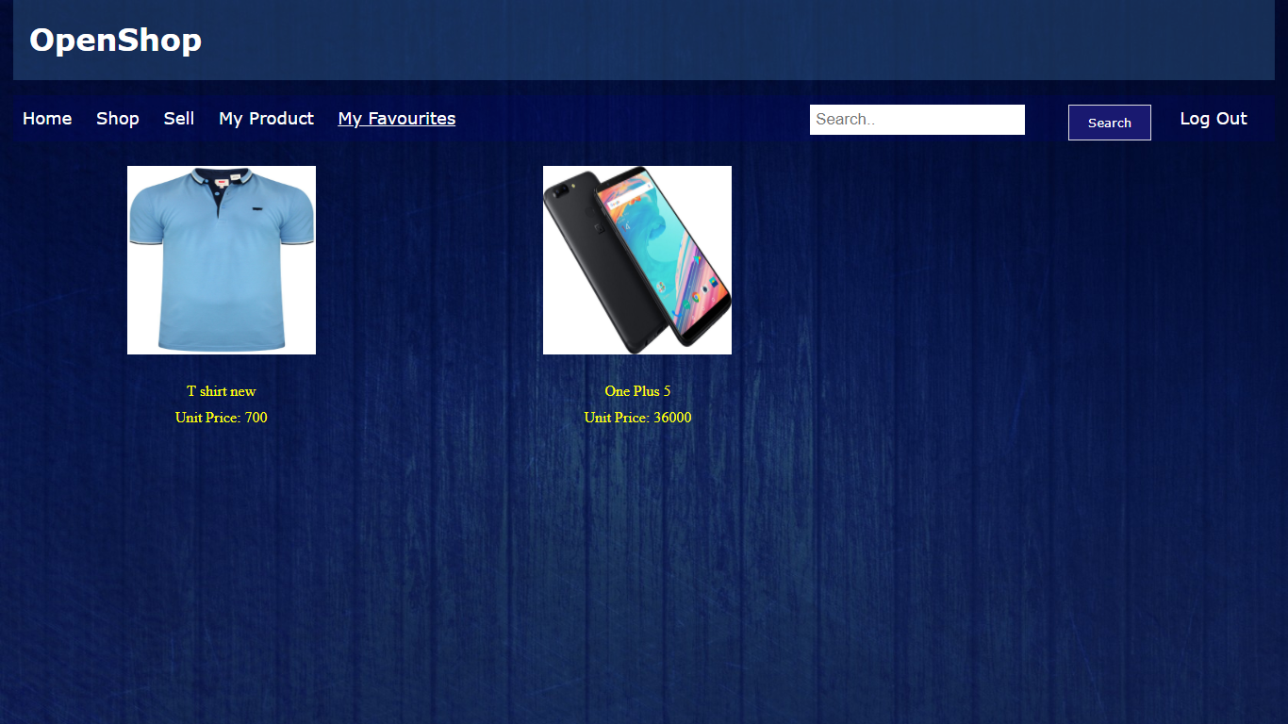

Users can keep tag of the products they are interested to buy in ‘my favourites’ page.

* This is our buying page.

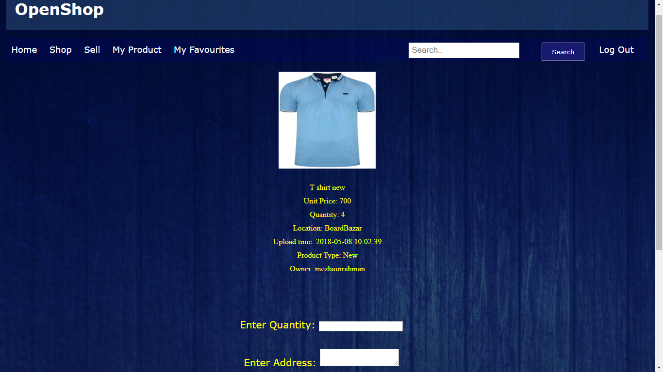

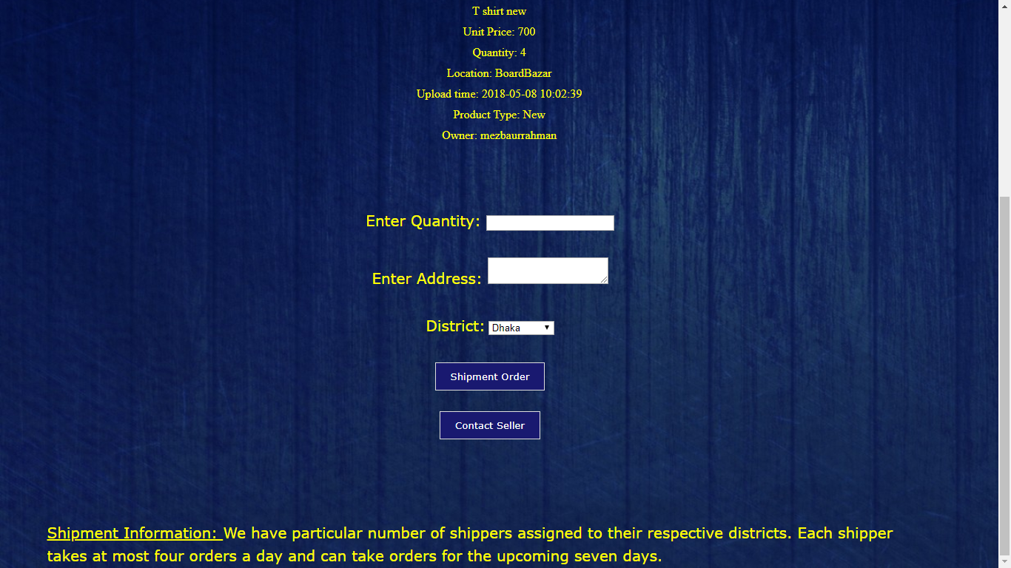

* This is our purchase details via shipment order page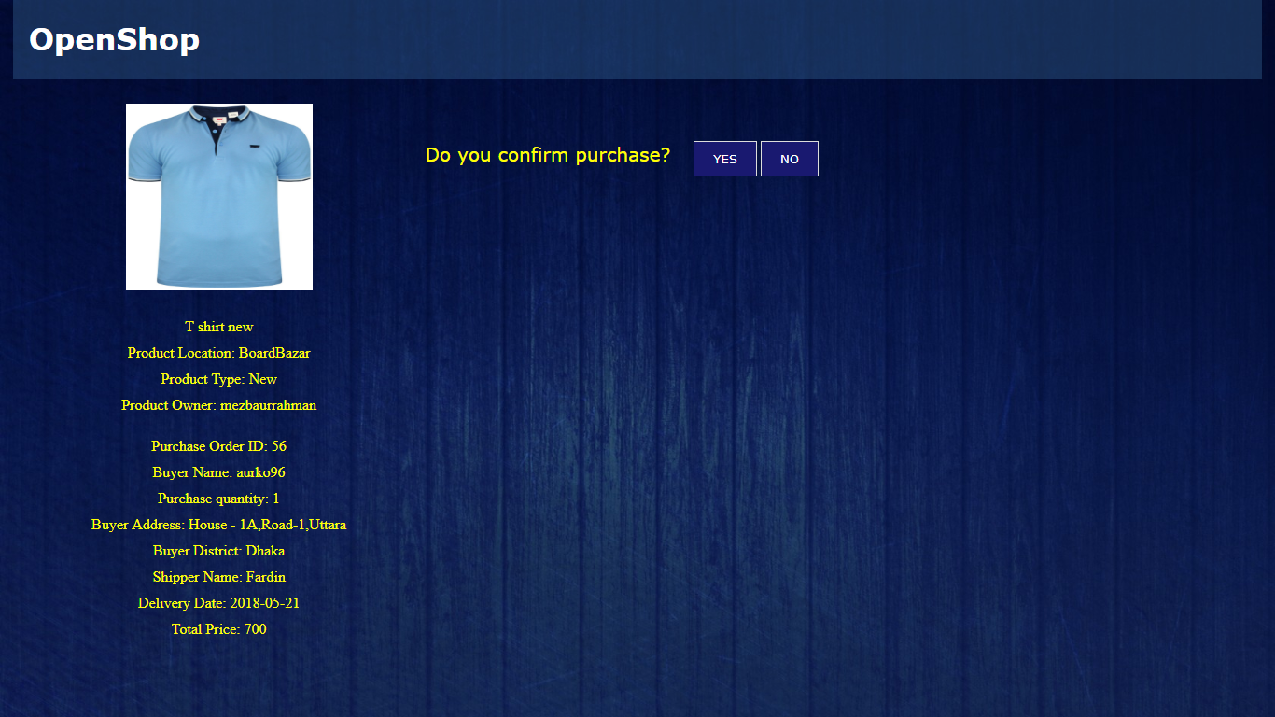

If YES button is pressed then the order will be confirmed and consider purchased otherwise if NO button is pressed then the order will be cancelled.

* The image below shows all the tables in the project database in PhpMyAdmin.

